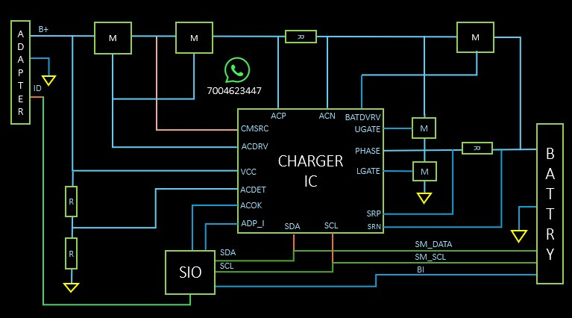
- Adapter ID Pin
Charger ID PIN SIO ko batati hai ki kitne WATT 45/65 ki adapter lagi hui hai.
- Agar CMSRC nhi detect hui to, ACDRV banna band ho jayegi.
- Battery charging ke liye LDO banana Jaruri hai.
- Battery Charging requirements
BIOS (LDO 3.3 v honi chahiye pull ke through)
SIO (LDO3.3 v honi chahiye pull ke through)
Battery Presert (LDO honi chahiye pull ke through - high hai to low aur low hai to high)
- SM_DATA (LDO3.3 v honi chahiye pull ke through)
- SM_SCL(LDO3.3 v honi chahiye pull ke through)
- BI (LDO3.3 v honi chahiye pull ke through).
- AC OK (LDO3.3 v honi chahiye pull ke through)
Note SIO ACOK ko read krta hai agar 3.3 volt hai to adapter connected aur 0volt to adapter not connected, battery se chalega.

